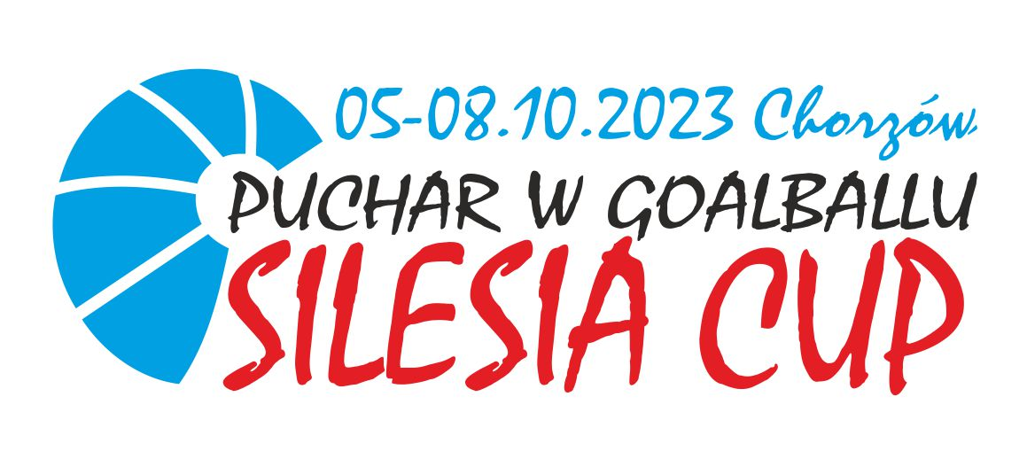

IMPORTANT INFORMATIONS

ACCOMODATION: FOCUS HOTEL CHORZÓW, ARMII KRAJOWEJ 15 STREET
SPORTS HALL: K.S. HAJDUKI CHORZÓW, GRANICZNA 92 STREET
TECHNICAL MEETING: 21:00 THURSDAY – AT THE HOTEL
MEALS: BREAKFAST AND DINNER AT THE HOTEL / LUNCH AT THE SPORTS HALL
MEALS HOURS:
6:30-9:30 – BREAKFAST
18:30-21:30 – DINNER

13:30-15:30 – LUNCH ON FRIDAY AND SATURDAY
12:00-13:30 – LUNCH ON SUNDAY

TRANSPORT DETAILS:
WE PROVIDE TRANSPORT BETWEEN HOTEL AND SPORTS HALL, IF NEEDED. BELOW CONTACT TO DRIVERS:
DANIEL +48516255108
MICHAŁ +48537160474

